**EE230 – HW1 Report  
CMOS LNA**  
(@ 1.9 GHz & using 45nm CMOS Technology)

**Muhammad Aldacher**

**Student ID: 011510317**

1. **Schematic Setup:**

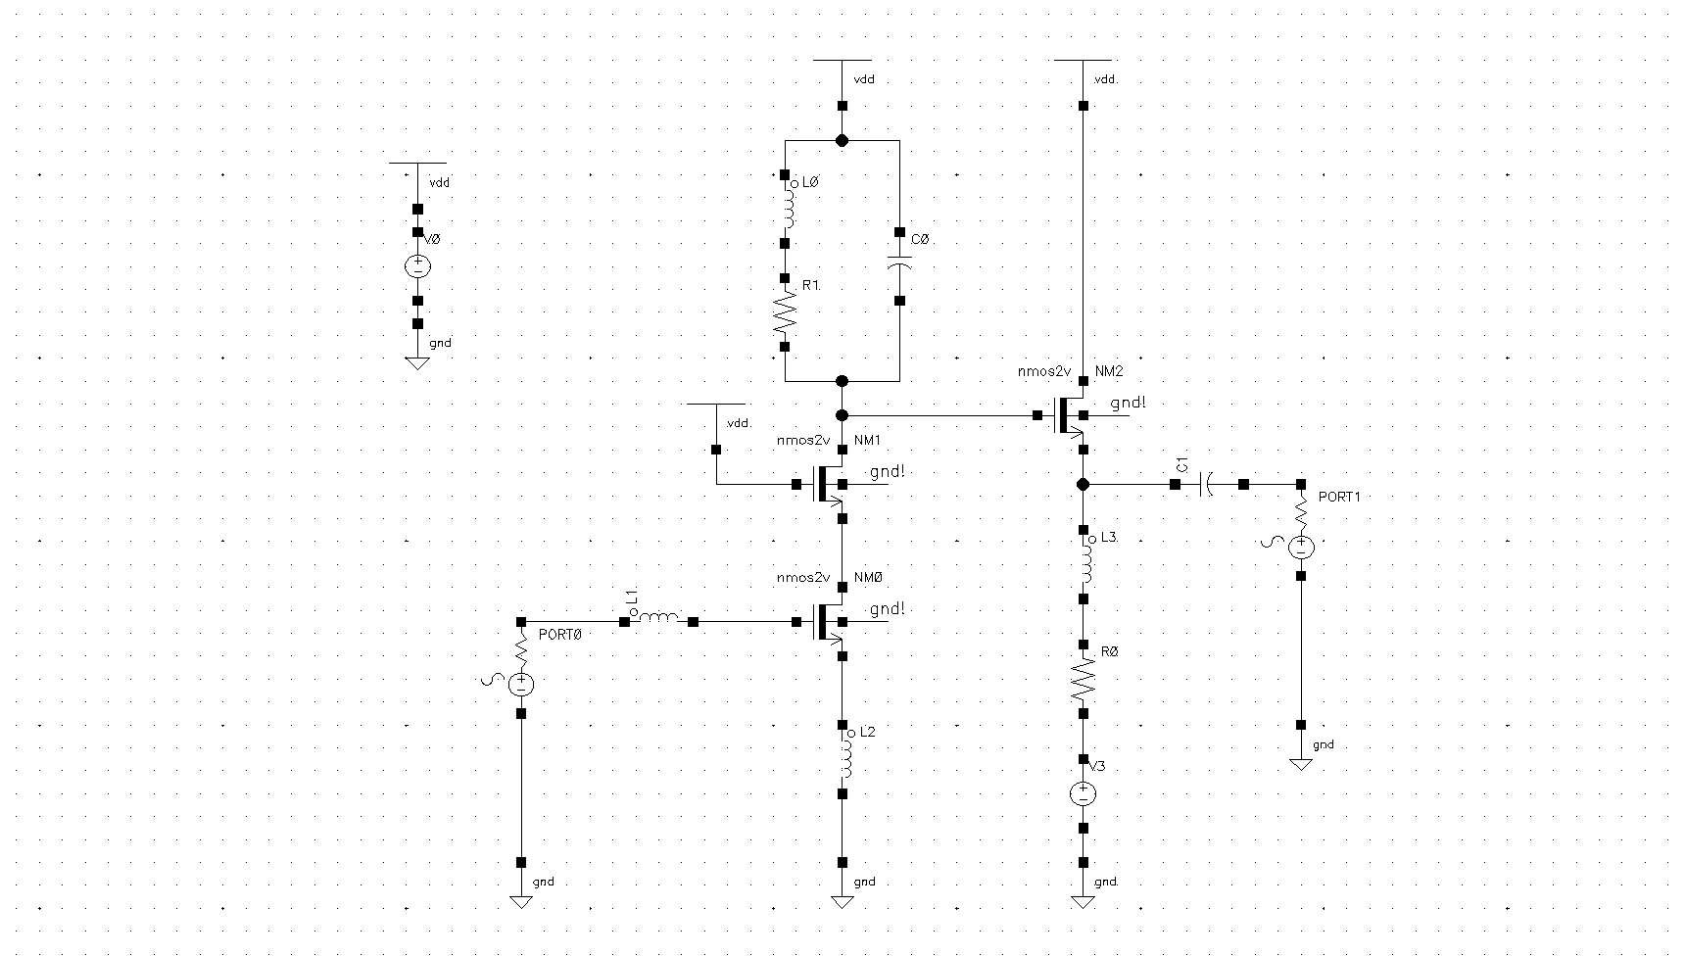

**Vb2**

**VDD**

Fig. 1. CS Cascode LNA schematic

|  |  |  |  |
| --- | --- | --- | --- |
| Transistor | W [um] | L [um] | Multiplicity |
| NM0 | 10 | 0.6 | 10 |
| NM1 | 5 | 0.6 | 10 |
| NM2 | 4 | 0.3 | 10 |

.

|  |  |
| --- | --- |
| Component | Value |
| L0 | 5.5 nH |
| L1 | 15 nH |
| L2 | 1.4 nH |
| L3 | 20 nH |
| R0 | 15 Ohm |
| R1 | 7.5 Ohm |
| C0 | 1.2 pF |
| C1 | 2 pF |
| VDD | 1.8 V |
| VDC(in) | 0.35 V |
| Vb2 | 0.76 V |

1. **S-Parameters & Noise Figure:**

|  |  |
| --- | --- |
| Parameter | Value @ 1.9GHz |
| S21 (Gain) | 20.0567 dB |
| S11 | -16.5097 dB |
| S22 | -30.0189 dB |

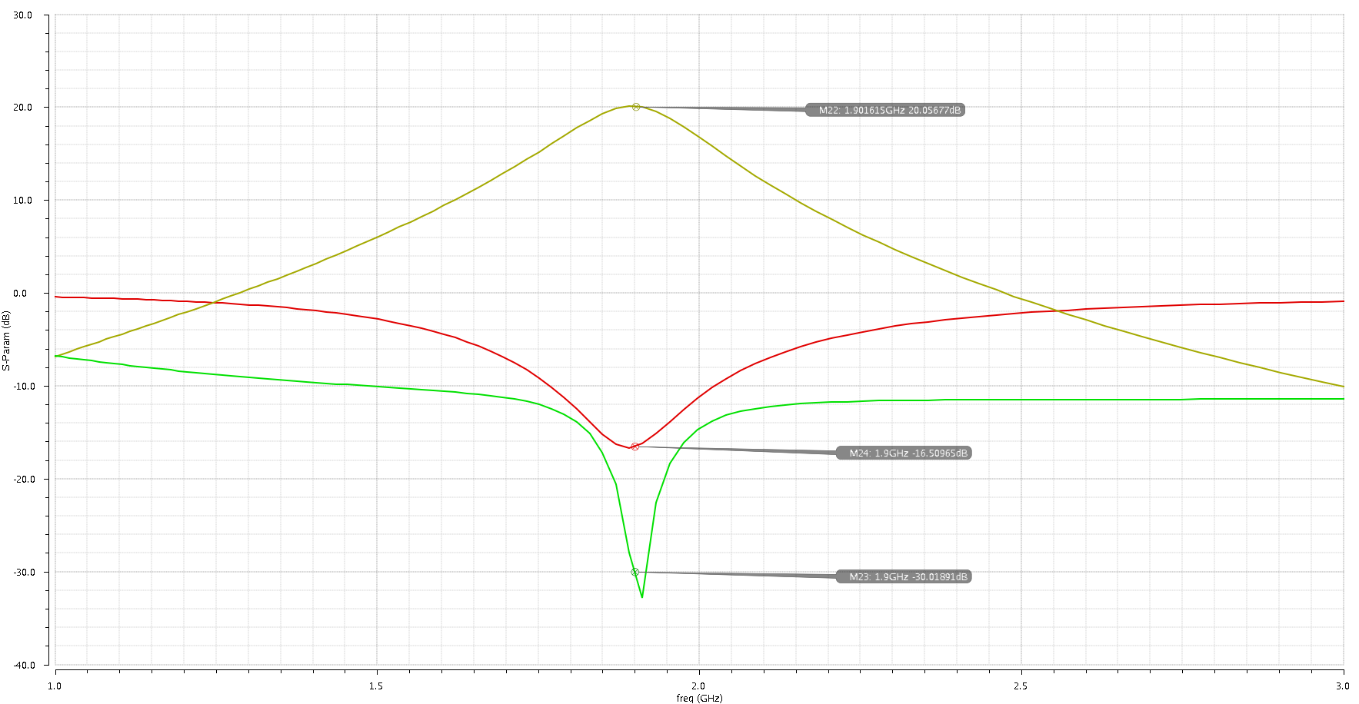

**S21 (Gain)**

**S22**

**S11**

Fig. 2. S-Parameters

|  |  |
| --- | --- |
| Parameter | Value @ 1.9GHz |
| NF | 0.9015 dB |

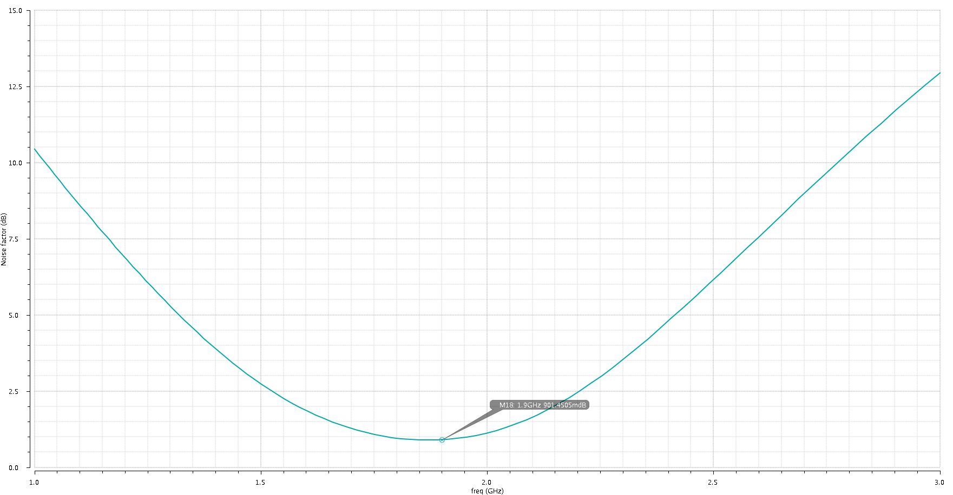

**NF**

Fig. 3. Noise Figure

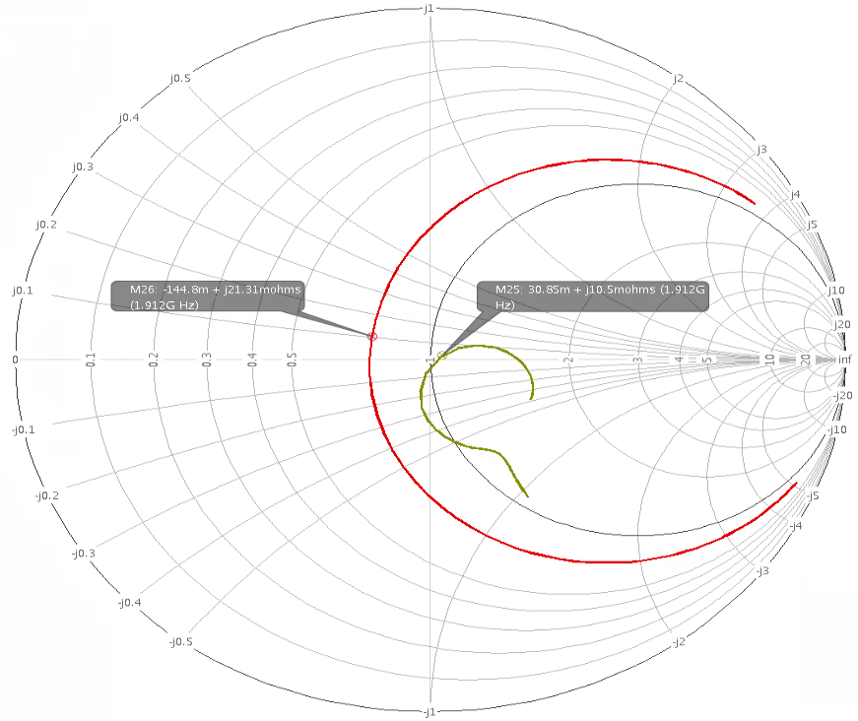

**S22**

**S11**

Fig. 4. Smith Chart for S11 & S22

1.1 Briefly describe the role of each transistor and passive component in the LNA.

* Transistors:
  1. **NM0**: is the Common-Source amplifier stage. Its main function is to amplify the input signal.
  2. **NM1**: is the Cascode stage. Its main function is to provide a separation between the input & output sides of the CS amplifier, preventing the feedback through CGD of NM0.
  3. **NM2**: is a Common-Drain stage. It acts like a buffer between the LNA & the Mixer, and as a matching network to the output side. The impedances from the Mixer side would have almost no affect on the resonance frequency of the LNA by altering the LNA’s output impedance.
* Passives:
  1. **L1 & L2**: they are used to resonate with the input capacitance CGS at the resonance frequency & provide the equivalent resistance equal to 50 Ohms (along with gm). Since they provide the input matching, thus they affect the S11 parameter.
  2. **L0 & C0**: they resonate at the resonance frequency to provide the adequate gain at that desired frequency.
  3. **L3 & C1**: they are used to provide the output matching. So, they directly affect the S22 parameter (along with Vb2).
  4. **R0 & R1**: they represent the losses of the inductors L3 & L0, respectively, affecting their Q.

1.2 Describe in general terms, how is the input and output match implemented in this design.

* Input matching:

The input matching is provided by the inductors L1 & L2 along with the CGS & the gm of NM0. The Zin seen by the input port is given by the following equation:

Zin = s.(L1+L2) + +

The real part gives the 50 Ohm matching & (L1+L2) resonant with CGS at the desired frequency.

* Output matching:

The output matching is provided by the L-match network causing a downward impedance transformation using L3 & C1, from the impedance seen at NM2’s source to the 50 Ohm required to be matched with the output port.

1.3 Would the output buffer (transistor N4) and/or the output matching network to 50ohm be needed if the load of the LNA was a Mixer on the same chip? Explain.

* If the output of the LNA goes to a Mixer on the same chip, then the buffer & the matching network are not needed, since on-chip circuits avoid the 50 Ohm impedance, as it requires large power to drive it.

The output buffer could (but not necessary) provide a separation between the LNA & the Mixer to ease the design of each stage, as the capacitances from the Mixer won’t directly affect the output stage’s resonance of the LNA.

2.1 Run a DC Analysis and save the operating point. Display the operating point of transistor N0 and take note of its gm, vgs and cgs. Using these values calculate the theoretical gain, noise figure and input impedance of the LNA. Are the calculated values different from the S-parameter simulation results? Explain the differences.

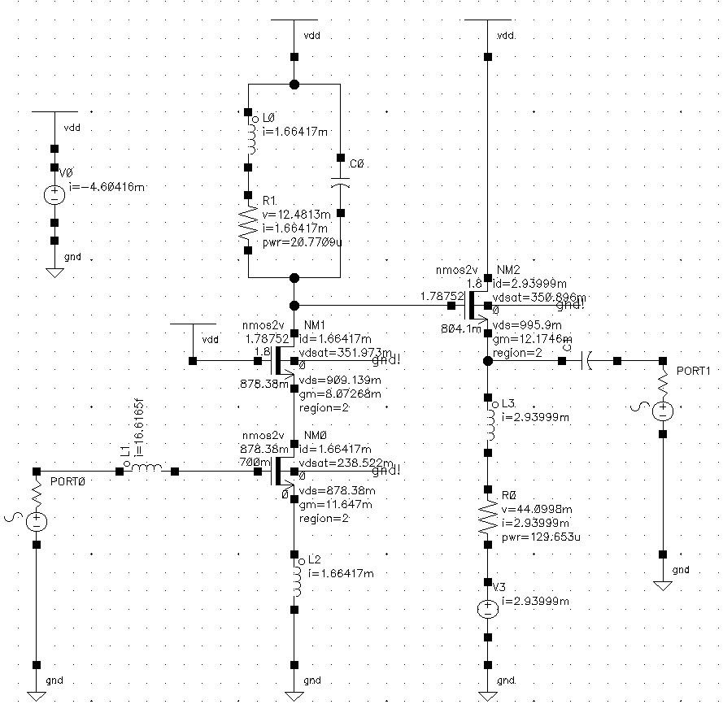

From DC Analysis:

|  |  |
| --- | --- |
| Parameter | Value |
| gm (of NM0) | 11.647 mS |
| CGS (of NM0) | 408.486 fF |
| Id (of NM0) | 1.664 mA |

Fig. 5. DC operating points

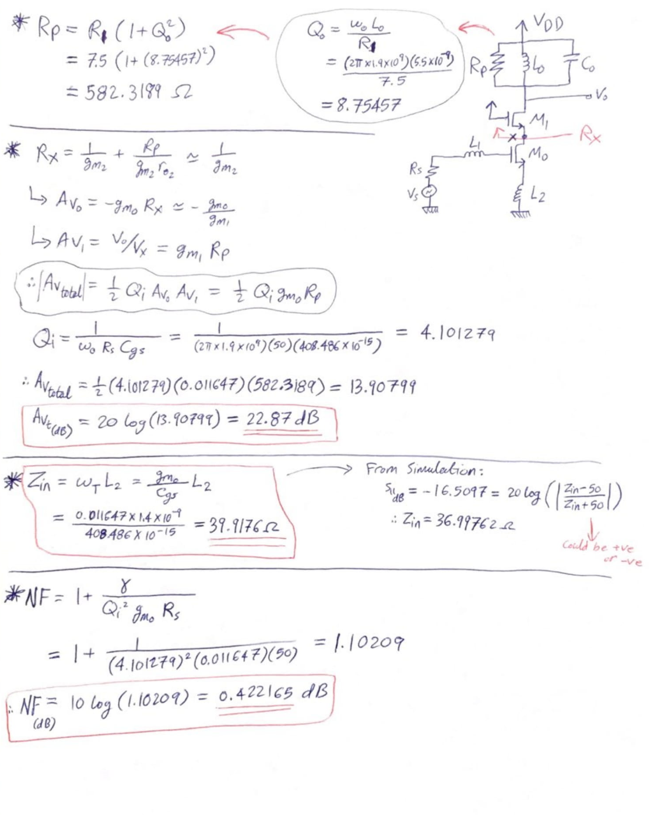

|  |  |  |
| --- | --- | --- |
| Parameter | Simulations Value | Hand-Calculations Value |
| Zin | 36.9976 Ohms | **39.9176 Ohms** |
| Gain | 20.0567 dB | **22.8653 dB** |
| NF | 0.9015 dB | **0.4222 dB** |

The differences arise from the many approximations that were made in the hand calculations. So, for the **Gain** calculations, an approximated value of Rx (looking into the source of NM1) & Qin were used, in addition to having **Zin** calculated without considering the effect of CGD. For the **NF**, the noise contributions from the cascode transistor & the load were neglected.

1. **PSS Simulation:**
   1. **Single-tone Simulation:**

PRF (input) = -40 dBm:

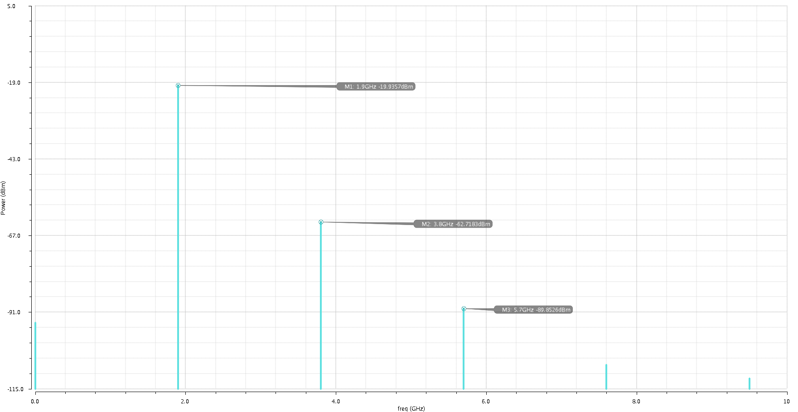

Fig. 6. Output spectrum for a –40 dBm 1.9 GHz input

PRF (input) = -20 dBm:

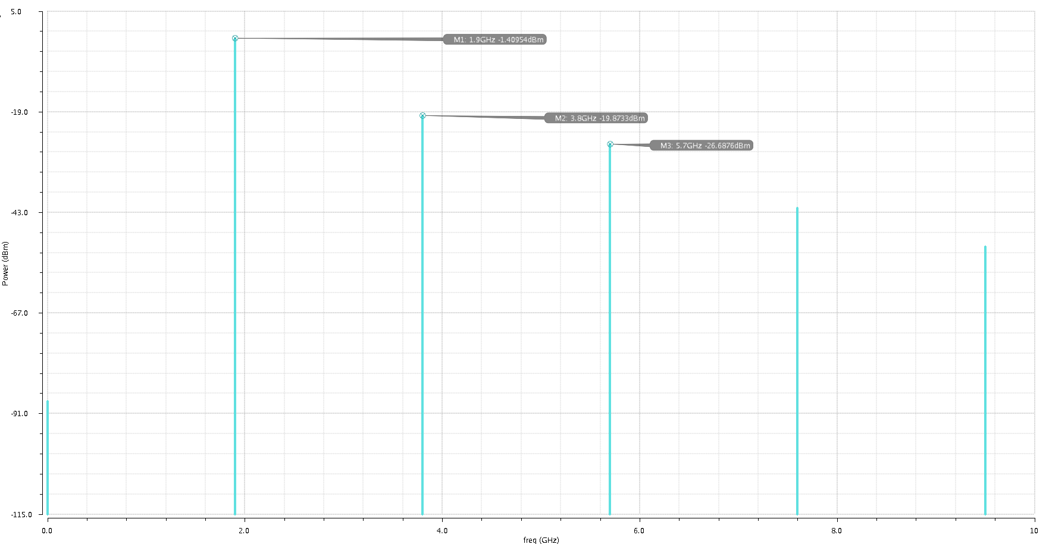

Fig. 7. Output spectrum for a –20 dBm 1.9 GHz input

PRF (input) = -5 dBm:

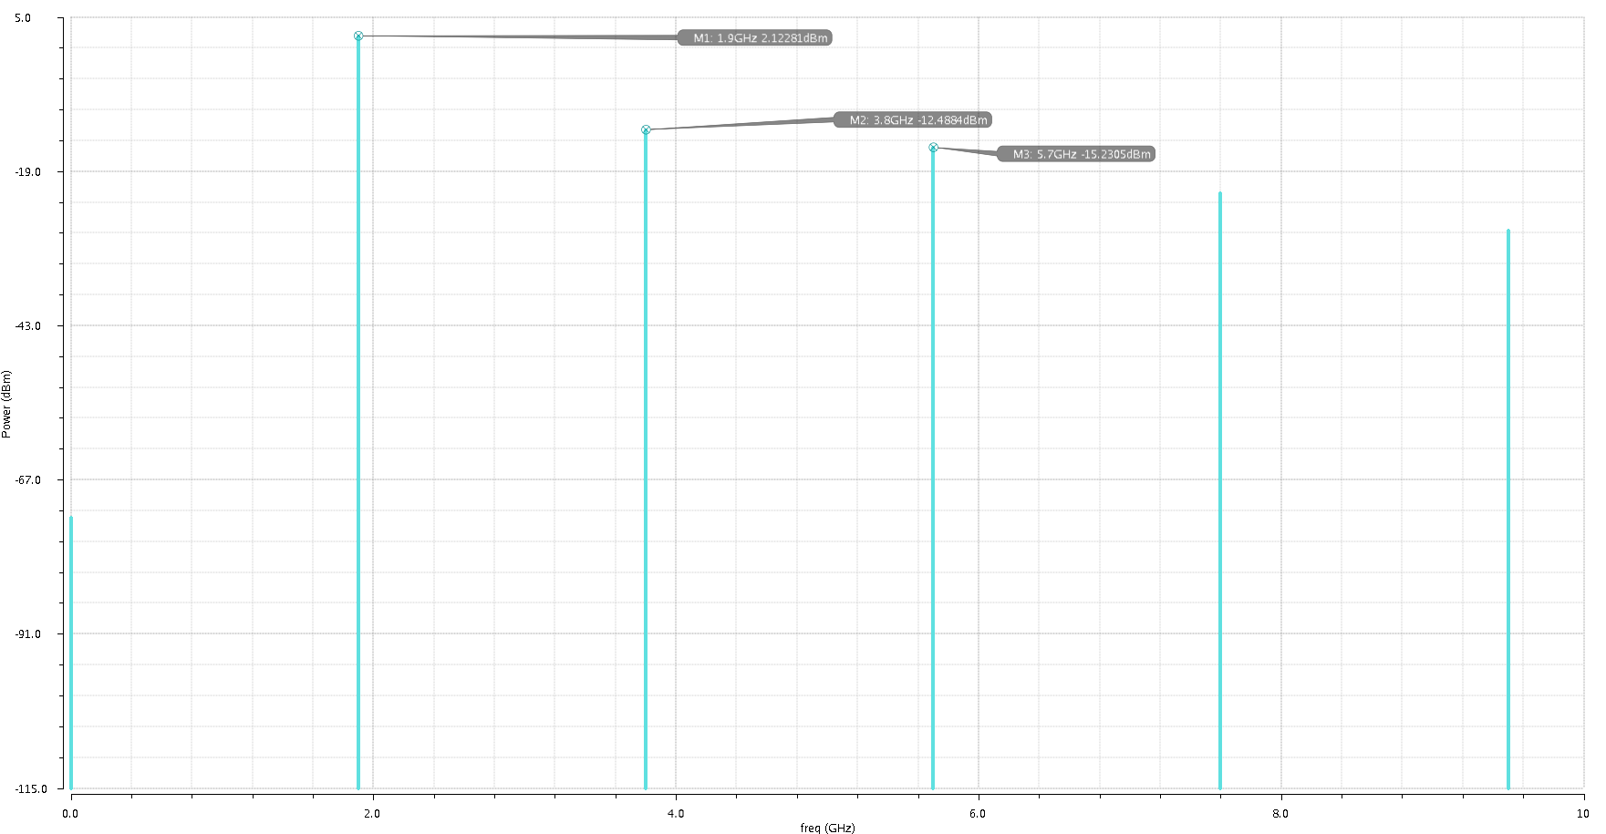

Fig. 8. Output spectrum for a –5 dBm 1.9 GHz input

3.11 What is the power gain of the LNA for the fundamental tone? What is the HD2 and HD3? How do these 3 parameters change for an input of -40dBm and -5dBm?

|  |  |  |  |  |  |  |
| --- | --- | --- | --- | --- | --- | --- |
| PRF (input) | Fund. Tone | Gain | 2nd Harmonic | HD2 | 3rd Harmonic | HD3 |
| -40 dBm | -19.936 dBm | -19.936-(-40)  = **20.064 dB** | -62.718 dBm | -62.718-(-19.936)  = **-42.78 dB** | -89.853 dBm | -89.853-(-19.936)  = **-69.92 dB** |
| -20 dBm | -1.410 dBm | -1.410-(-20)  = **18.590 dB** | -19.873 dBm | -19.873-(-1.410)  = **-18.46 dB** | -26.688 dBm | -26.688-(-1.410)  = **-25.28 dB** |
| -5 dbm | 2.123 dBm | 2.123-(-5)  = **7.123 dB** | -12.488 dBm | -12.488-(2.123)  = **-14.61 dB** | -15.231 dBm | -15.231-(2.123)  = **-17.35 dB** |

* From these results, we can see that as the input power increases (from -40dBm to -5dBm), the Gain of the fundamental tone starts to decrease at a certain point (around ~ 20dBm) due to gain compression. The HD2 & the HD3 increase as the input power increases, showing that the system becomes more non-linear as the input power increases.
  1. **Two-tone Simulation:**

PRF (input) = -40 dBm:

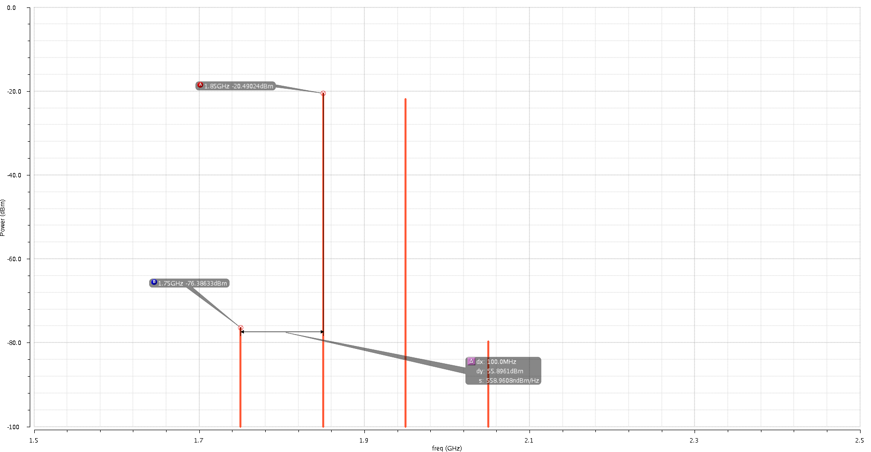

**ΔP**

Fig. 9. Two-Tone test output using PSS

3.21 From the PSS simulation results, what is the IIP3 of this LNA?



1. **PSS Simulation:**
   1. **Single-tone Simulation:**

|  |  |
| --- | --- |
| Parameter | Value @ 1.9GHz |
| P1dB | -21.7495 dBm |

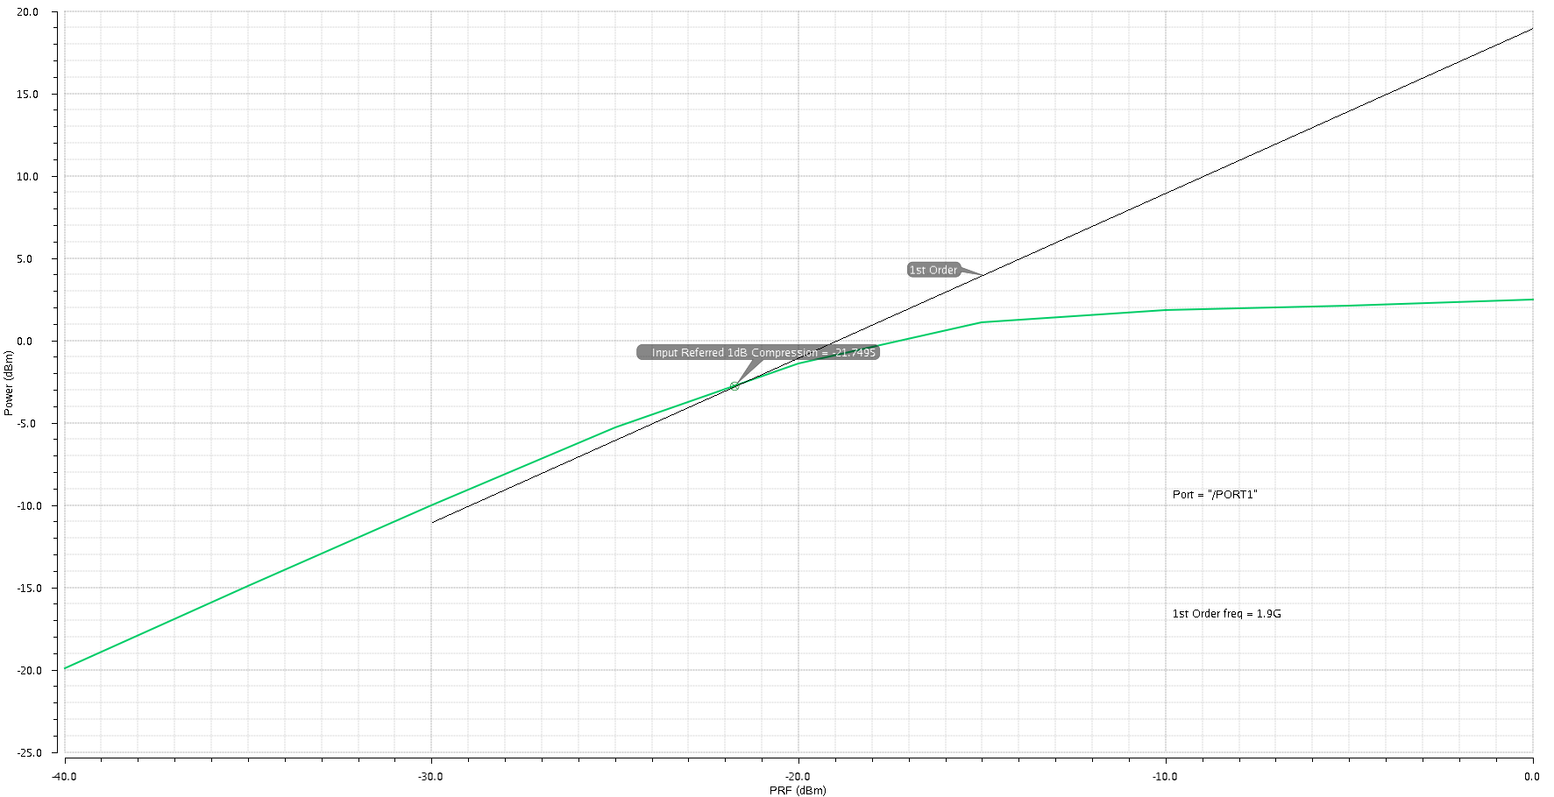

Fig. 10. Input 1dB compression point

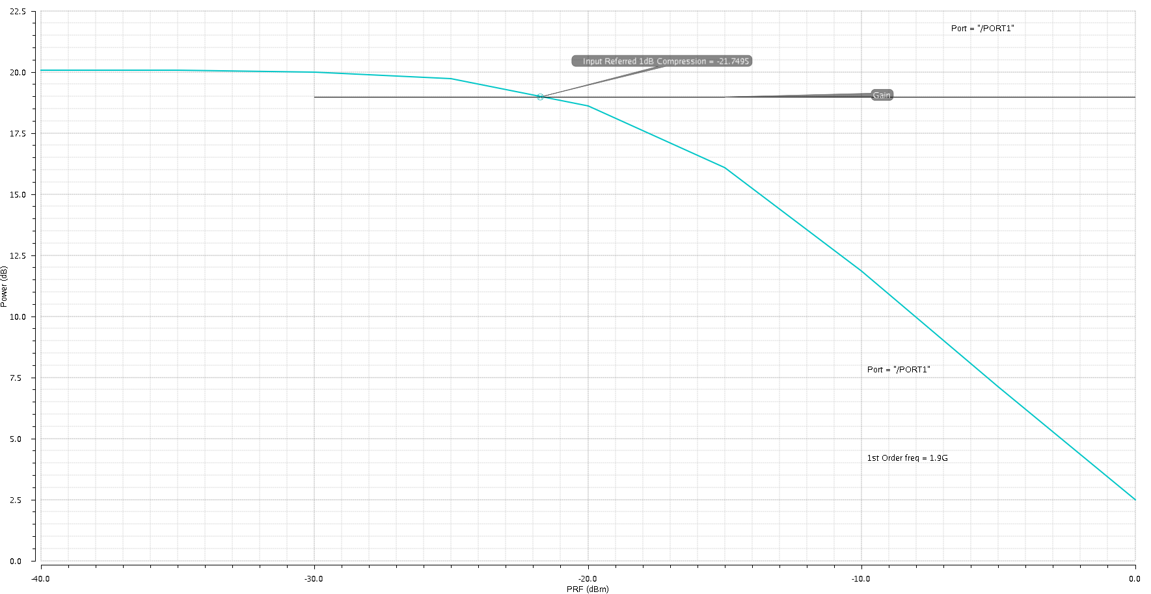

Gain (dB)

Fig. 11. Gain Vs. Input Power

* 1. **Two-tone Simulation:**

|  |  |
| --- | --- |
| Parameter | Value |
| IIP3 | -11.1408dBm |

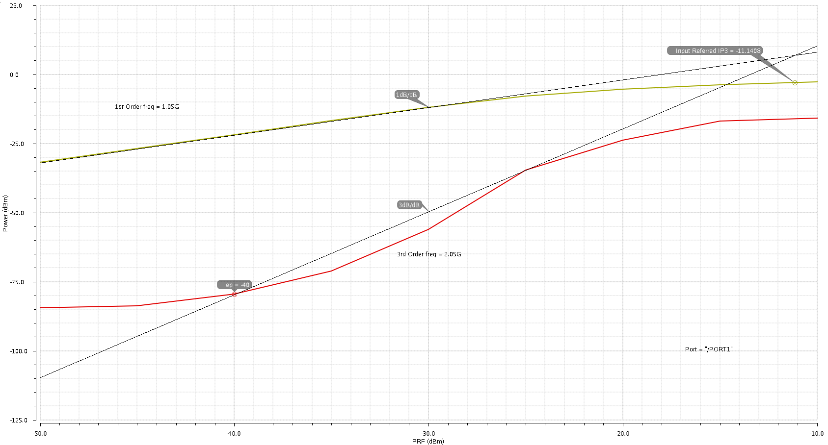

Fig. 12. Main tones & intermodulation products, with the extrapolated IIP3

4.21 How does the extrapolated IIP3 compare with your calculation from 3.21? Is the difference between the 1dB compression point and the IIP3 what you would expect?

* The extrapolated IIP3 is very close to that calculated from the two-tone test output spectrum, since the equation used for the calculation in 3.21 is derived from the extrapolated plots.
* The measured difference between the IIP3 & the P1dB is -11.1408 –(-21.7495) = **10.6087 dB**, which is close to the expected value as shown below:

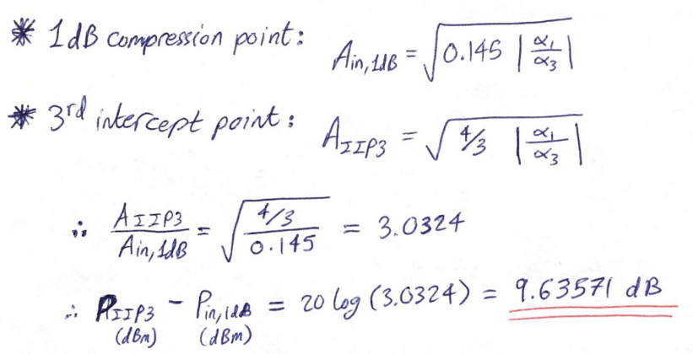

1. **Summary of the results:**

|  |  |
| --- | --- |
| **Parameter** | **Value @ 1.9 GHz** |
| Gain | 20.0567 dB |
| S11 | -16.5097 dB |
| NF | 0.9015 dB |
| S22 | -30.0189 dB |
| P1dB | -21.7495 dBm |
| IIP3 | -11.1408 dBm |
| P dissipated (by the main LNA stage) | 1.664 mA x 1.8 V  = 2.995 mW |
| P dissipated (Total = LNA + Buffer) | (1.664 mA+ 2.94 mA) x 1.8 V  = 8.287 mW |